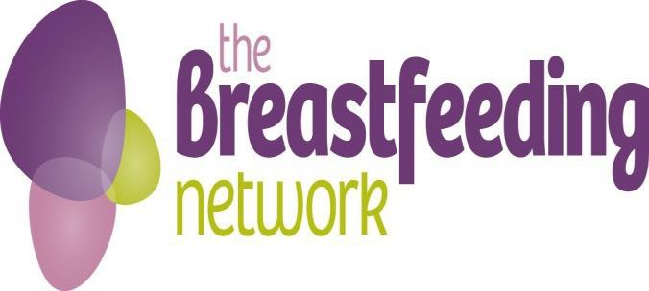

Job Description for Scottish Development Officer for National Breastfeeding Helpline

**About the role:**

This is a flexible, part time, home based role, working as part of the small National Breastfeeding Helpline and Scotland teams, who are home based. The role is varied, and involves promoting the helpline and helpline engagement throughout Scotland. This role is key to the organisation as we strive to reach more families in Scotland to make them aware of the support is offered by the Helpline; as well as the training and development volunteering opportunities available.

**Role Summary**

* To help promote the National Breastfeeding Helpline (NBH) and Drugs in Breastmilk (DIBM) services to families, health professionals and other key referral channels across Scotland.
* To support and significantly increase the coverage of National Breastfeeding Helpline (NBH) and BfN Supporterline by engaging with Registered Breastfeeding BfN Supporters in Scotland
* To develop and deliver evidence-based plans to increase the number of contacts for support (calls and social media messages) received from Scottish callers.
* Working with other members of the BfN team, to develop and post relevant content to engage callers across Scotland and the UK via social media
* To contribute to organizing regular study day events in Scotland for volunteers

**Main duties and responsibilities**

* Regularly review NBH data gathered on social media engagement and helpline and DIBM usage across Scotland to inform development and delivery of plans to address BfN and commissioner agreed targets
* Promote and market the National Breastfeeding Helpline and DIBM service to families and health professionals in Scotland through:
  + identifying, attending and speaking at relevant events and conferences
  + working with healthcare professionals, Health boards, HSCPs and local authorities to identify opportunities to promote the helpline
  + development and posting of content via social media and other channels
* Support the work of the Helpline Volunteer Coordinator for Scotland to engage as needed with Supporters in the specified region to increase volunteering on the helpline and social media
* Work with BfN colleagues to create, post and monitor engaging content for NBH social media accounts
* Attend and/or present to relevant groups and conferences about the Helplines as and when required.
* Assist with researching and organising suitable speakers for BfN and NBH events
* Use initiative to come up with suitable, low cost ideas and incentives to motivate, thank and encourage volunteer recruitment and promotion of the helpline in Scotland
* Contribute to plans to remove barriers to accessing NBH support, especially for families from diverse backgrounds, areas of high deprivation and where English is not their first language
* Collate useful feedback and engagement data to help improve the service we offer.
* Take part in monthly telephone conferences with other NBH colleagues and NBH Manager
* Take part in regular meetings with the Scottish programme manager and service managers to discuss coordination of activity in Scotland
* Provide statistical information as and when required by Directors, colleagues or local projects.
* Contribute to Scottish Government and other reporting as needed

**Additional responsibilities**

* Abide by the policies of the BfN with regards to Health and Safety, Fire Policy, Child Protection, Safe Home visiting, Lone Worker Policy, Confidentiality, Data Protection and any new policies which come into use
* Attending annual updates
* To follow BfN Code of Conduct

*This is not an exhaustive job description and may be subject to change according to the needs and development of the role. It is expected that the post holder may undertake such other duties as may be reasonably requested.*

**NBH Scottish Development Officer Person Specification**

**Please refer to this document carefully when completing your application form and preparing for your interview. You must demonstrate how you meet the criteria on your application form.**

|  |
| --- |
| Essential |
| * Currently living in Scotland * Strong knowledge of BfN and NBH * Knowledge of the Infant Feeding culture in Scotland and the specific issues and barriers that can impact on families * Proven ability to effectively develop partnerships and secure strong engagement from other organisations and decision-makers * Proven ability to work and engage effectively with people from a wide range of cultures and backgrounds * A space to work at home and secure and reliable internet and phone access * Willing and able to drive own car and able to travel to events across Scotland if necessary * Experience of producing and posting engaging social media (FaceBook, Instagram, X, video etc.) content * Commitment to importance and application the BfN Code of Conduct * Commitment to the BfN Equality and Diversity Policy * Ability to speak and write fluently in English * Ability to communicate effectively and accurately in a variety of ways (telephone, email, text, public speaking) with people at different levels * Ability to interpret numerical data * Ability to organise own work, problem solve and manage work independently * Ability to work effectively as part of a ‘virtual’ team * Ability to keep the confidentiality of volunteers and others * IT skills including Word and Excel, email and internet use * Ability to maintain records and write reports |

|  |
| --- |
| Desirable |
| * Currently registered as a BfN Helper or Supporter or has completed peer support training with another organisation * Good understanding of Scottish healthcare context for breastfeeding families * Experience of volunteering with BfN and/or NBH * Experience of working with diverse ethnic and social groups * Experience of public speaking and presenting * Experience or good understanding of marketing and communications activities |