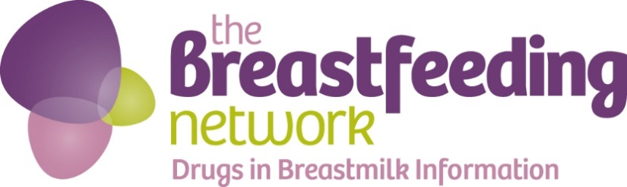

The Breastfeeding Network and our Drugs in Breastmilk Helpline would like to invite you to run, chat with a mate and eat cake as part of our annual BfN Big Tea Break event to raise awareness and start conversations about the important issue of maternal mental health

The Breastfeeding Network (BfN) has been running a Drugs in Breastmilk (DIBM) information service offering independent, evidence-based, confidential information and support via a trained pharmacist and volunteer since 1995. The demand for the service has increased every year. We receive on average 550 emails per month from health professionals and Mums as well as around 30 questions and requests for support every day via our facebook page (@BfNDrugsinBreastmilkinformation). The service does not provide individual clinical advice or diagnosis and information is kept up-to-date with the latest evidence from authoritative sources.

We do not tell mums what to do, we simply provide evidence based information to allow women to make informed decisions about medical treatment and feeding her child, alongside discussions with healthcare professionals.

Around 15-20% of the questions we receive are related to anti-depressants, coping with anxiety and other mental health issues. There has been a significant rise in these questions over the last few years. Many mums are told by healthcare professionals that they will have to stop breastfeeding in order to take anti-depressants simply because there is insufficient readily-available information about the safety of drugs in breastmilk. Rarely do we see that stopping breastfeeding is justified by evidence of the passage of the drug into breastmilk.

We also have detailed information sheets on anxiety, OCD, bipolar disorder and depression medication, which can all be downloaded by a mum for her own use or to show to her doctors: https://www.breastfeedingnetwork.org.uk/breastfeeding-ad-perinatal-mental-health/ Together these sheets receive thousands of views every month.

Background information:

- It is estimated around 10-15% of mothers develop perinatal mental health issues, usually within 6 weeks of giving birth.
- A large scale study last year showed that women who breastfed their babies were at significantly lower risk of developing PND than those who did not. The study also showed that the risk of PND was higher amongst those mums who wanted to breastfeed but were unable to.
- Mothers who choose to breastfeed and who also need treatment for PND or mental health issues need extra specialist information and support to inform their choice to breastfeed. Mothers who need to take medication are often advised to stop breastfeeding.
- The World Health Organisation recommends babies are exclusively breastfed for their first six months, with continued breastfeeding along with appropriate foods up to two years of age or beyond.
- Breastfeeding rates in the UK are amongst the lowest in the world. More than 3 in 5 mums stop breastfeeding before they want to. This figure is higher for Mums who breastfeed and need to take medication

The DIBM service is highly regarded. There are no other services in the UK that offer this type of support and information specifically for breastfeeding mums. Many organisations refer to the line including the NHS, Unicef Baby Friendly initiative, National Childbirth Trust, La Leche League GB, Association of Breastfeeding Mothers and Migraine Trust amongst others.

In 2011 an external evaluation of the DIBM helpline concluded it provides an important service for breastfeeding mums and healthcare professionals: http://www.internationalbreastfeedingjournal.com/content/7/1/6

In 2014 we asked service users to complete a survey about the helpline, and received hundreds of positive responses, including:
“The helpline has saved me and my daughters many times over. I can honestly say I would have committed suicide after my 2nd baby was born had it not been for your support to keep taking my meds and to keep breastfeeding.”
Mum

“The information is presented in a way which is accessible to non-medical mothers to understand, but also written in a way that doctors who know little about breastfeeding will take seriously.”
Consultant Paediatrician

More information about maternal/perinatal mental health
It is estimated that more than 1 in 10 women will develop a perinatal mental health issue. Perinatal mental health refers to any mental illness that occurs from during pregnancy and for the first year after birth. There are several different types of mental illness that can affect mothers, often the first one people think of is postnatal depression, but perinatal mental illness also includes antenatal depression, maternal OCD, postpartum psychosis and post-traumatic stress disorder. These illnesses can be mild, moderate or severe and can require a whole range of support, care and treatment.
You can find out more about maternal/perinatal mental health on these websites

http://www.nhs.uk/conditions/Postnataldepression/Pages/Introduction.aspx
https://gpifn.org.uk/maternal-mental-health/
www.app-network.org.uk
www.maternalocd.org
http://www.mind.org.uk/information-support/types-of-mental-health-problems/postnatal-depression/#.Ve6qF_lVikp
http://www.rcpsych.ac.uk/healthadvice/problemsdisorders/postnataldepression.aspx
http://www.maternalmentalhealth.org.uk/
http://www.rcgp.org.uk/clinical-and-research/toolkits/perinatal-mental-health-toolkit.aspx

To raise awareness of maternal mental health and to raise funds to support the Drugs in Breastmilk service we are asking people to join in with our virtual run and to hold BfN Big Tea Break events between 1st and 31st October 2017.

There is lots more information, including a guide to running an event, all the resources you need (apart from the tea and cake!) and details of the virtual run challenge and how to register on our website https://www.breastfeedingnetwork.org.uk/bfns-big-tea-break/
Thank you

