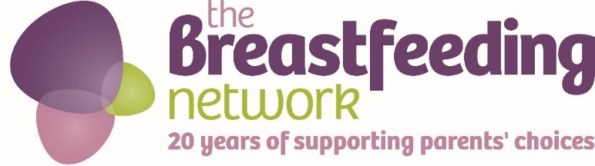

Do you enjoy sharing tea and cake with friends?

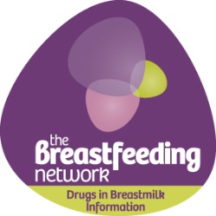
Could you organise a ‘BfN Big Tea break’ to talk about maternal mental health and to support our Drugs in Breastmilk Information service?

It is very easy to do and you can download everything you need from our website
https://www.breastfeedingnetwork.org.uk/bfns-big-tea-break/

Why not hold an event for local mums or friends and family as a chance to bring everyone together and raise money while you have a tea break!

You could also organise a Big BfN Tea Break at work for your colleagues and have cake for them to buy to go with their tea. We can provide free CPD materials for your event and you can drink tea, eat cake and raise money while you work!

Before your event
- Choose a venue, it could be your house or a friend’s house or book a local hall if you are organising a bigger event.
- Pick a date and time– It could be any time during October and whatever time suits you and the people you are inviting best (A middle of a night shift tea break? cake for breakfast anyone?!)
- Let people know about the event – you can download free posters to either print out or use on social media
- Decorate your room using our free downloadable bunting (there is even a tiny version to use on cakes!)
- If you are organising the event for your work colleagues, have a look at our free CPD and see if it would be useful for you – that way you have an even better excuse for all getting together!

Raising money
The event is about having fun, taking a break, talking about mental health and sharing tea and cake, but there is also a serious aim to raise money to support our Drugs in Breastmilk information service. Here are some ideas for raising money at your event –
- Charge people a small amount for coming along to your event
- Organise a ‘Bake off’ and get people to pay £3 to enter a cake into the competition, we have provided voting slips and you could charge people £3 to have one and vote for their favourite cake. You could have different categories (Tastiest cake, most beautiful cake, most creative cake etc) or just one overall winner. The winning baker could get a small prize!
- Ask people to guess the weight of a cake for £1 and the closest guess wins the cake
- Have a donation box available for people to donate to on the day, we have provided information for you to have available to let guests know what the event is all about and how the money raised will help support the Drugs in Breastmilk service

During the event
- Make sure you take time to relax, drink tea and eat lots of cake and have fun!
- Thank people for coming along and supporting the event
- Let people know about the #teabreakchallenge and encourage them to share a photo of their tea break, nominate a friend who also deserves a tea break and then text a donation using DIBM88 £3 to 70070
- Take lots of photos and share them with us by
  - Emailing fundraising@breastfeedingnetwork.org.uk
  - On our Facebook page @BfNDrugsinBreastmilkInformation
  - On Twitter using #BfNteabreak

After the event
- Share out any leftover cake (if there is any!)
- Count up the money raised and let us know your final total by emailing fundraising@breastfeedingnetwork.org.uk including your name and the location of your event
- Use our BACs details below to pay in the money raised or pay it in directly via our JustGiving appeal page if you prefer. Please use ‘Big Tea Break’ as a reference for the payment.

BACS details
The Breastfeeding Network
Account no. 06001963
Sort Code 800929

JustGiving page
www.justgiving.com/drugs-in-breastmilk-helpline-appeal
Just Text Giving – Text DIBM88 £3 (or any amount up to £10) to 70070

Why not also sign up for our BfN Big Tea Break virtual run? Run, chat with a mate and eat cake! More information on our website

