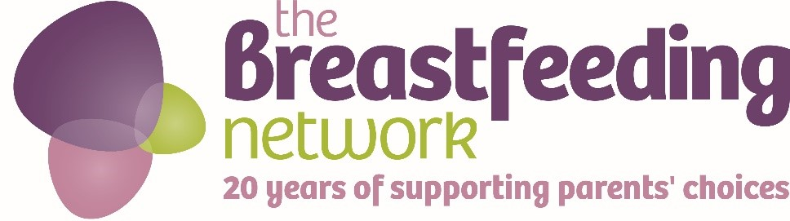
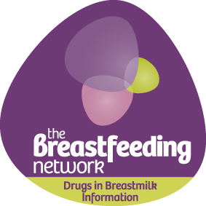

Come and join us for the
‘BfN’s Big Tea Break’

Take some time to meet up, chat to friends, have fun and support the
Drugs in Breastmilk Information service

When:

Where:

#DIBM #BfNteabreak #teabreakchallenge

To donate text DIBM88 £the amount you wish to donate to 70070 eg DIBM88 £5 to 70070

www.breastfeedingnetwork.org.uk/detailed-information/drugs-in-breastmilk/

The Breastfeeding Network is a registered Scottish charity no. SC027007
The Breastfeeding Network is a company limited by guarantee registered in Scotland company no. 330639

