Certificate of Participation

Well Done

You have just taken part in Mums’ Milk Run 2016
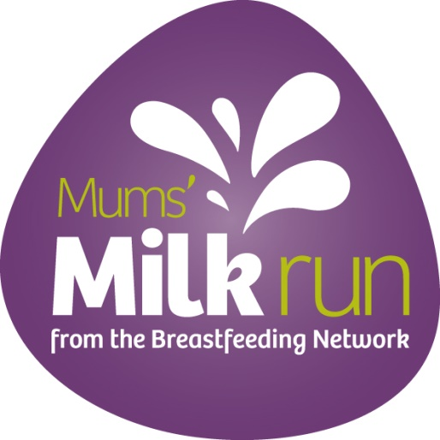
Building a community of Support

Thank you

The Breastfeeding Network is a Company Limited by Guarantee Registered in Scotland Company No. 330639
Registered office Alexander Sloan, Chartered Accountants, 38 Cadogan Street, Glasgow, G2 7HF
The Breastfeeding Network is a Registered Scottish Charity No SC027007

