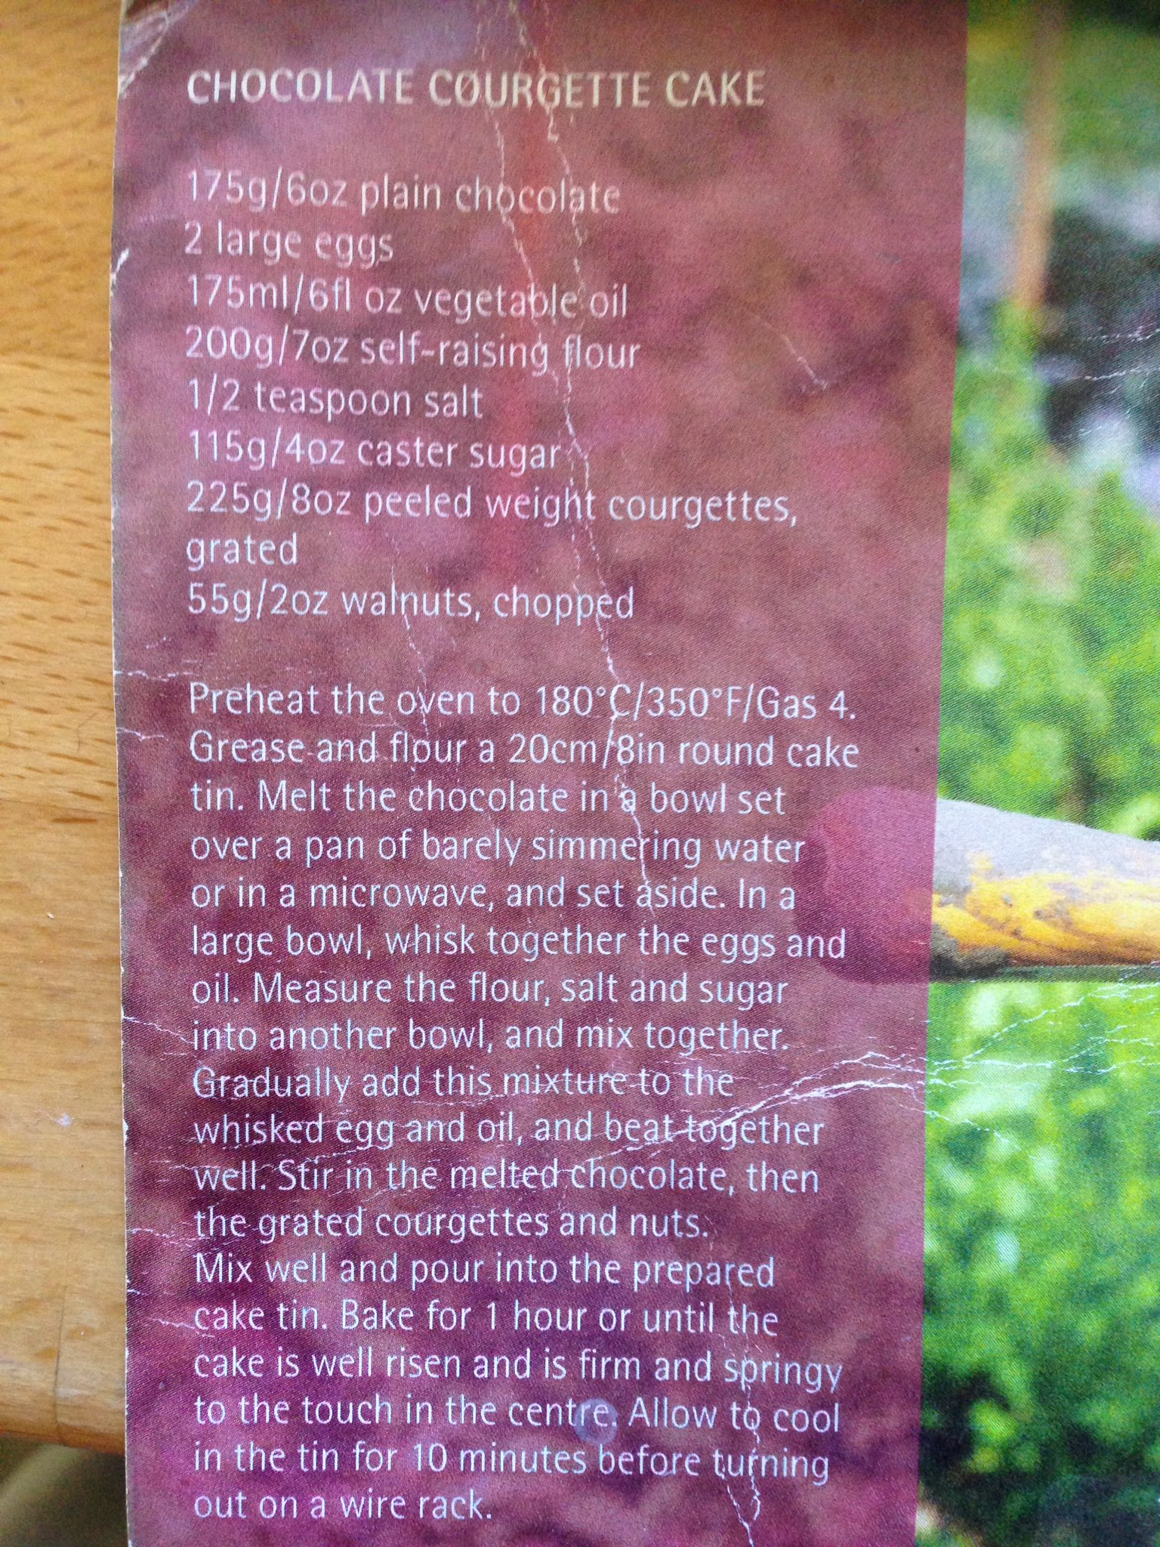
Chocolate Courgette cake – recommended by @NellyPlants

