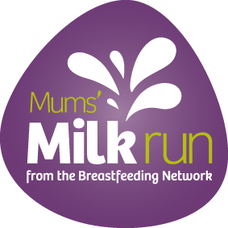
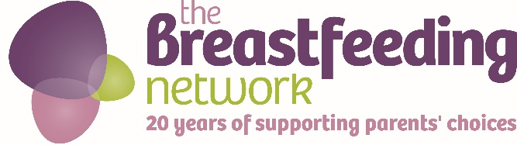
Mums’ Milk Run 1st-20th May 2017
The Breastfeeding Networks’s annual national fundraising event, Mum’s Milk Run, will be held this year between 1st and 20th May 2017. This year we are celebrating our 20th birthday and we would like to invite families, friends and volunteers to come together to help us fundraise across the UK.
Add details here of your local event or individual challenge, you could also say a little bit about why you are fundraising for the BfN
Thank you for your support, all money raised will be used to help more families be able to access the support and information they need to help them get off to a good start with breastfeeding.

Name(s) of participants…………………………………………………………….

Name | Address | Postcode (essential for Gift Aid) | Amount | Gift Aid (Please tick) | Tick if paid

Total Raised______________

Gift Aid (Make your donation worth 28% more. Please note, you must be a taxpayer paying more tax than the amount we reclaim in order for us to claim Gift Aid from your sponsorship)

Please return your sponsorship form and payment to your local breastfeeding centre or post to The Breastfeeding Network, PO Box 11126, Paisley, PA2 8YB. You can also pay in any money collected directly using our JustGiving page https://www.justgiving.com/breastfeedingnetwork/ or join our Mums’ Milk run team at https://www.justgiving.com/teams/MMRteam2016

For more information please contact xxxxxxx or email xxxxxxxxxx (add in your own details here)
The Breastfeeding Network is a Company Limited by Guarantee Registered in Scotland Company No. 330639
Registered office Whitelaw Wells, 9 Ainslie Place, Edinburgh, EH3 6AT
The Breastfeeding Network is a Registered Scottish Charity No SC027007

