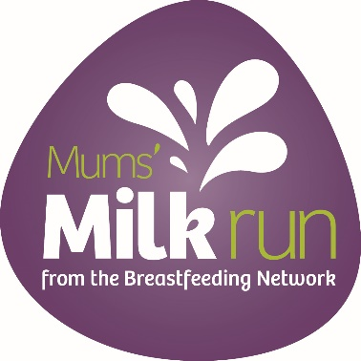
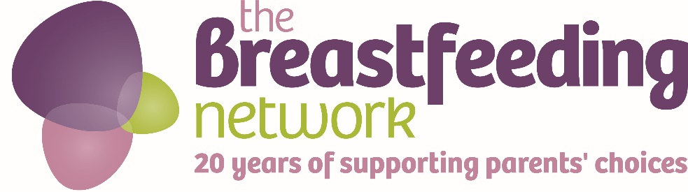
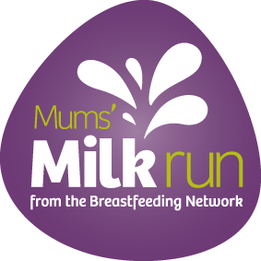

Mums’ Milk Run 1st-20th May 2017
The Breastfeeding Networks’s annual national fundraising event, Mum’s Milk Run, will be held this year between 1st and 20th May. This year is our 20th birthday and we are asking families and volunteers to come together to help us fundraise an ambitious total of £20,000 over the year.

Add details here of your local event or events, you could also say a little bit about why you are fundraising for the BfN and the difference fundraising might make in your area.
Make sure you include the date, time and venue for your event and also who it is suitable for eg all the family, just mums, toddlers and older children or smaller babies etc
We would love to hear about your events – please tweet @BfN_UK to tell us what you are doing and we will help you publicise your event

#mumsmilkrun2017 #mumssupportingmums #BfN20
For more information please contact xxxxxxx or email xxxxxxxxxx or look on our website

http://www.breastfeedingnetwork.org.uk/get-involved/fundraising/mums-milk-run/

To speak to a Mum who knows about breastfeeding call National Breastfeeding Helpline 0300 100 0212
Calls to 0300 numbers cost no more than calls to UK numbers starting 01 and 02 and will be part of any inclusive minutes that apply to your provider and call package
The Breastfeeding Network is a Company Limited by Guarantee Registered in Scotland Company No. 330639
Registered office Whitelaw Wells, 9 Ainslie Place, Edinburgh, EH3 6AT
The Breastfeeding Network is a Registered Scottish Charity No SC027007

