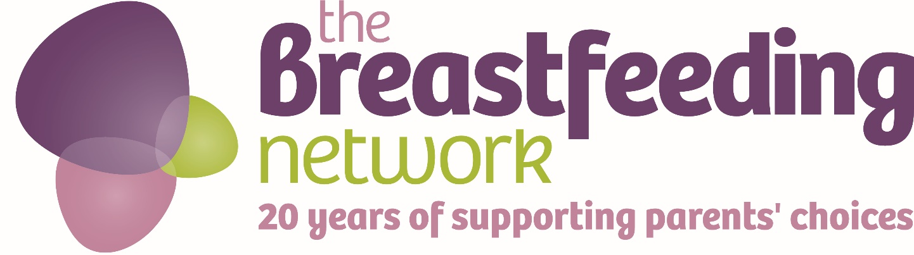

Certificate of Participation

Well Done
You have just taken part in Mums’ Milk Run 2017
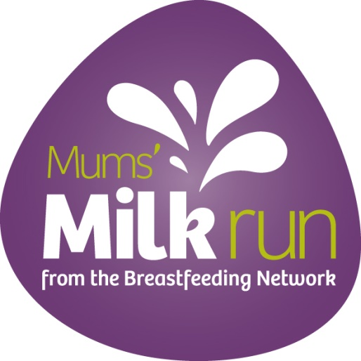
#BfN20 #mumsmilkrun2017
Thank you

The Breastfeeding Network is a Company Limited by Guarantee Registered in Scotland Company No. 330639
Registered office Whitelaw Wells, 9 Ainslie Place, Edinburgh, EH3 6AT
The Breastfeeding Network is a Registered Scottish Charity No SC027007

